+593% Organic Traffic in 90 Days: A New York PI Case Study

SEO

Results that speak for themselves

Key Stats & Results


+3,014 additional monthly organic visits to a single service page in just 3 months

Recognized by ChatGPT as a top recommendation for “Buffalo car accident lawyer” searches

Behind the transformation

How a Personal Injury Law Firm Increased Auto Accident Traffic by 593%
When this New York-based personal injury law firm partnered with Rankings.io, the objective was clear: Turn strong offline brand recognition into dominant organic visibility for one of its highest-value practice areas.
.

FROM CHALLANGES TO SUCCESS


How Started: The Challenge
Through a focused, page-level SEO and AI search strategy, the firm achieved rapid and measurable growth in just 90 days, including a top-3 ranking for a critical money keyword and a 593% increase in organic traffic to a single service page.
This established personal injury law firm has served accident victims across New York State for decades, building a powerful reputation through consistent results, strong brand awareness, and a client-first approach.
Like many high-volume personal injury firms, it faced some common challenges:
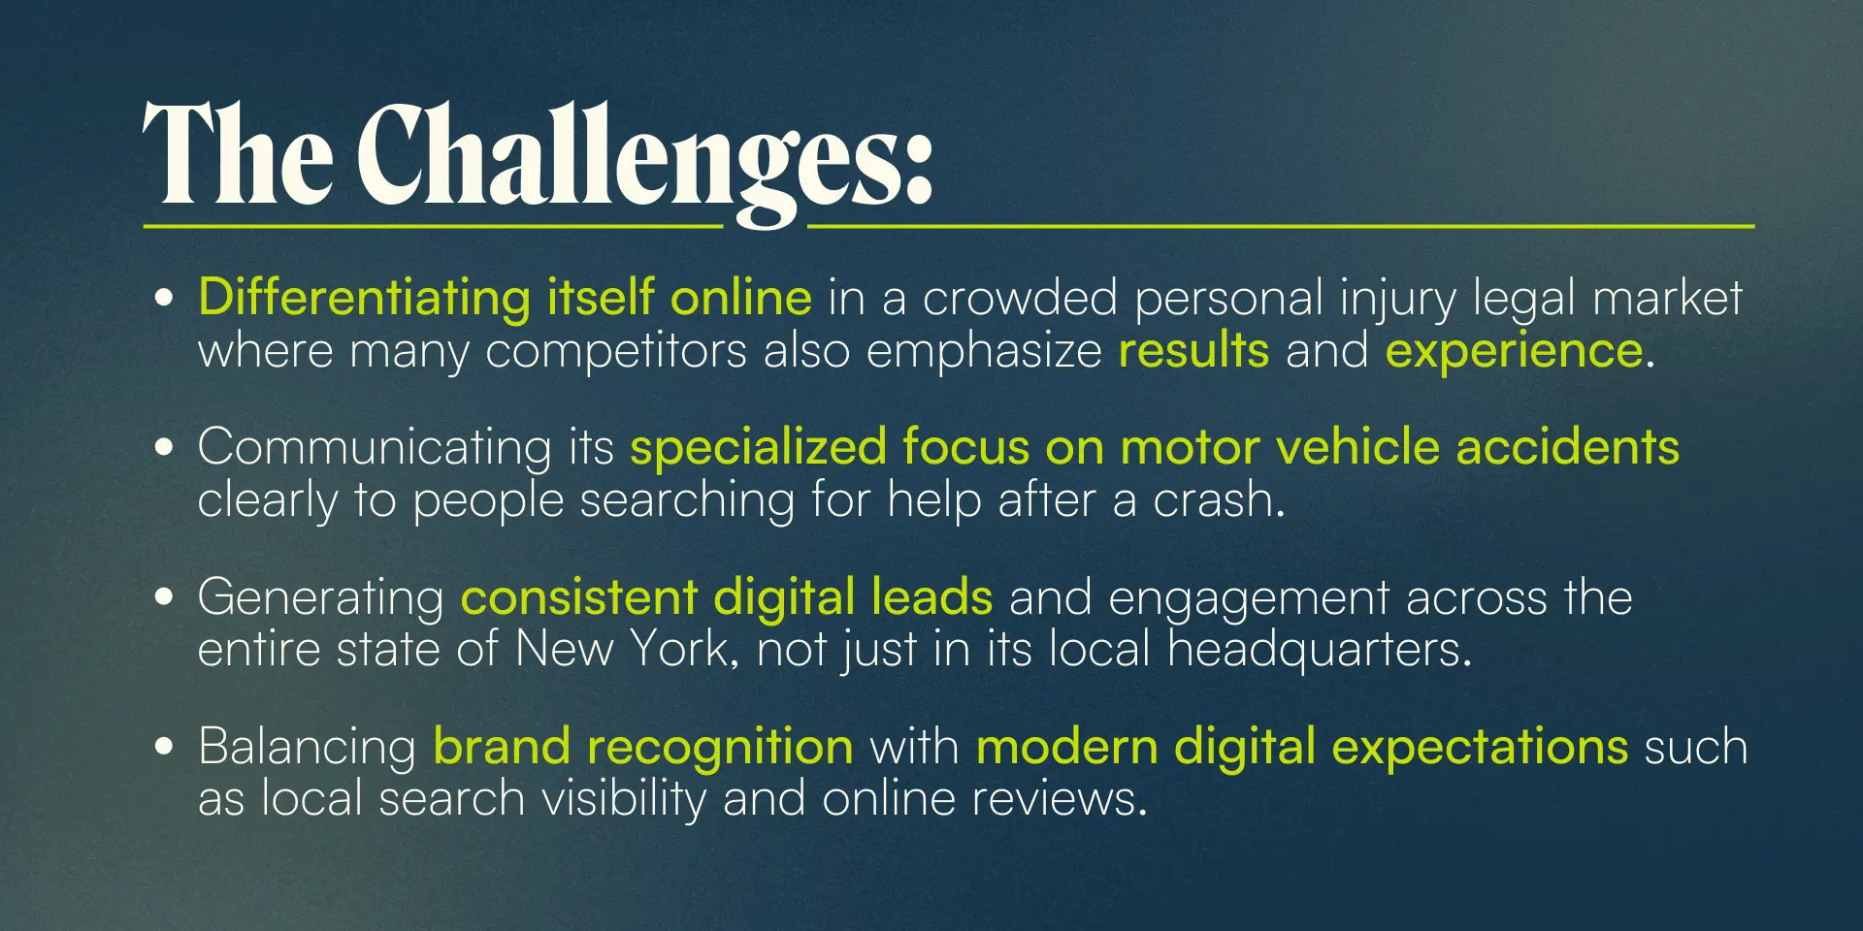



How We Did It: The Strategy
In just three months, Rankings.io executed a focused SEO + AI search strategy designed to improve visibility for a high-value auto accident money page.
Rather than spreading efforts across the entire site, we prioritized page-level impact, allowing us to generate meaningful organic growth within a tightly defined and measurable timeframe.

SEO Strategy for a New York Personal Injury Firm
Our approach focused on the core ranking factors required to win in a competitive legal market with specific emphasis on a local car accident practice area.

1. Technical SEO Foundation
We improved the website’s technical performance to ensure strong crawlability, usability, and search visibility. This included enhancements to site structure, mobile performance, page speed, and internal linking, allowing search engines to better understand and prioritize key practice area pages.

2. Content Strategy & Authority Building
We significantly improved the content quality of the Buffalo car accident page and expanded supporting onsite content to reinforce topical relevance. The content focused on clarity, depth, and legal expertise, helping establish stronger authority signals and better alignment with user intent.

3. Link Building & Digital PR
The launch of a new website with improved architecture and performance created a stronger foundation for SEO, enabling high-value practice area pages to perform more consistently in search results.

AI Search Optimization for Legal Discovery
As AI-powered search tools reshape how injured victims find lawyers, we optimized the page not only for Google rankings but for AI-driven recommendations.
Rather than treating AI visibility as a future concept, we aligned on-page SEO improvements with how large language models evaluate authority, clarity, and trust.

1. AI Search Visibility
We restructured the Buffalo car accident lawyer page to align with how AI systems identify and surface authoritative legal answers.
What we did:
- Rewrote core sections to clearly answer high-intent questions like:
  - Who is the best Buffalo car accident lawyer?
  - What should I do after a car accident in Buffalo?
- Strengthened entity clarity by reinforcing:
- Location relevance (Buffalo, NY)
- Practice focus (motor vehicle accidents)
- Improved heading hierarchy and semantic structure so AI systems could easily extract meaning, context, and authority signals.
AI-driven search tools prioritize pages that deliver clear, confident, and authoritative answers, not generic legal marketing copy.

2. Conversational Content Optimization
We optimized the content for natural-language legal queries, reflecting how real users now search and how AI models process information.
What we did:
- Reframed content to sound like direct responses, not keyword-stuffed explanations
- Added concise, plain-language explanations of legal processes and next steps
This significantly increased the likelihood of AI systems surfacing the firm as a recommendation — which ChatGPT validated when it identified the firm as a top result for car accident lawyer searches in its primary city.



Before & After: 90-Day SEO Impact
After three months of focused execution, the firm achieved measurable, page-level growth on a critical revenue-driving asset.
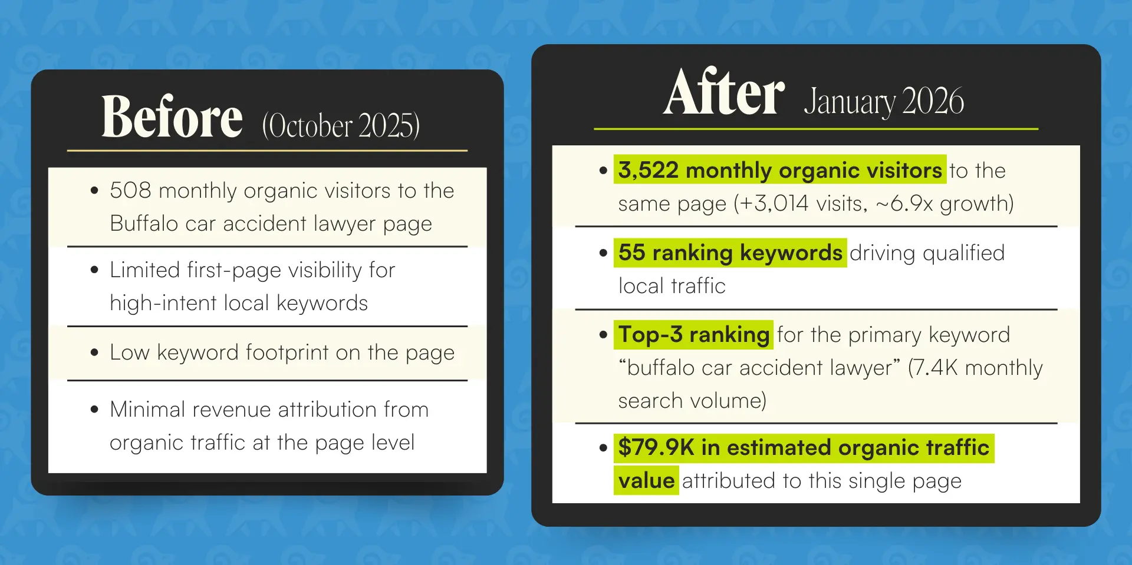
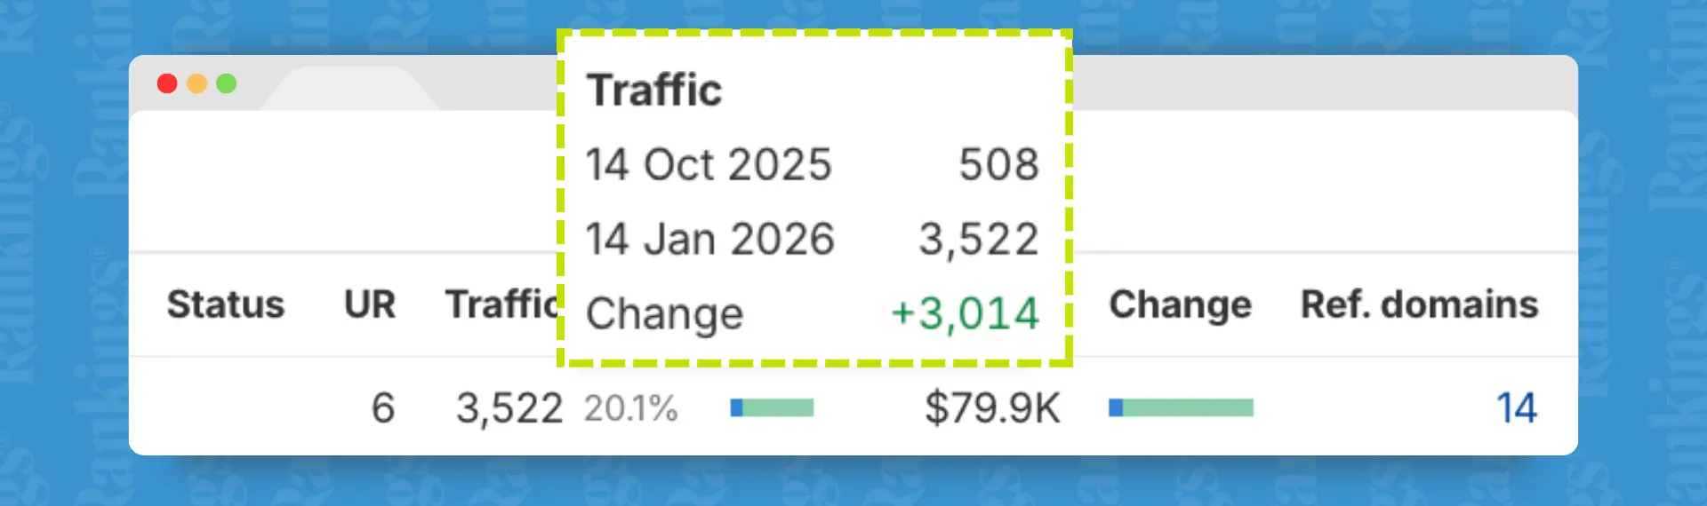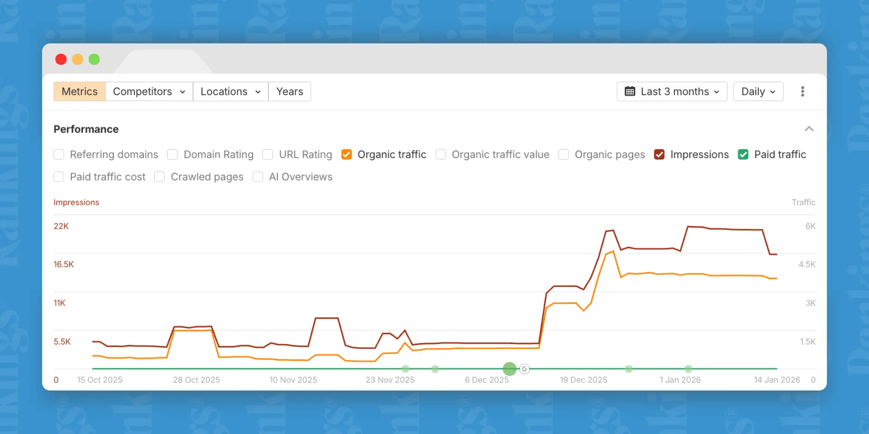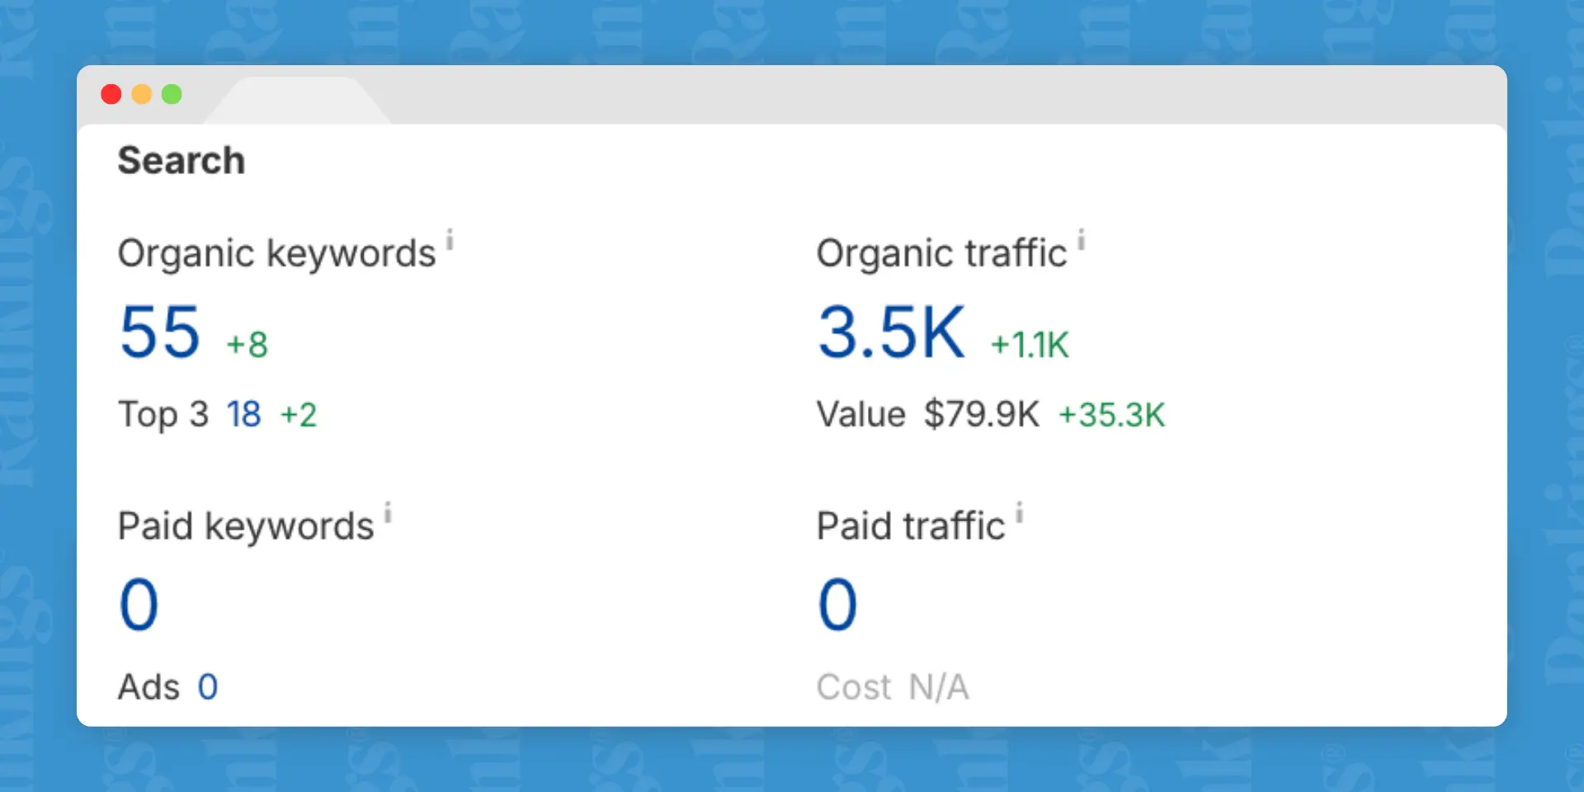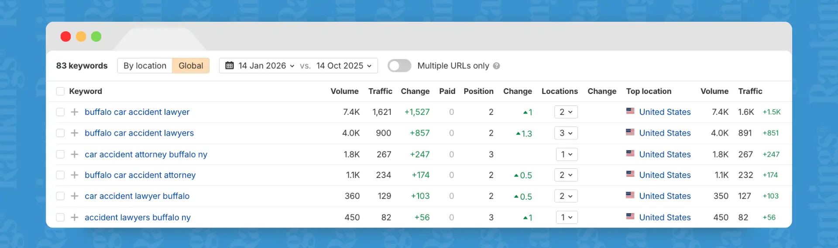

Key Wins
- Page 1 → Top 3 ranking for the primary money keyword (7.4K monthly searches)
- +3,014 additional monthly organic visits to a single page (508 → 3,522)
- 593% traffic growth in 90 days
- Expanded footprint to 55 ranking keywords
- $79.9K estimated monthly organic traffic value from one page
- Recognized by ChatGPT as a top recommendation for local car accident lawyer searches, reinforcing authority beyond traditional Google rankings

